Perform DFS using stack and BFS using Queues for the following graphs.
The graphs will be allocated by your Lab Incharges
Tabular Format should be followed while solving
Q. 1
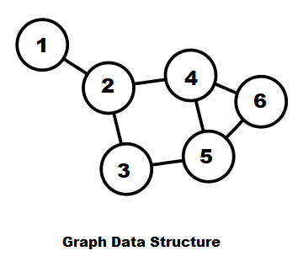
Starting vertex: 3
Q. 2
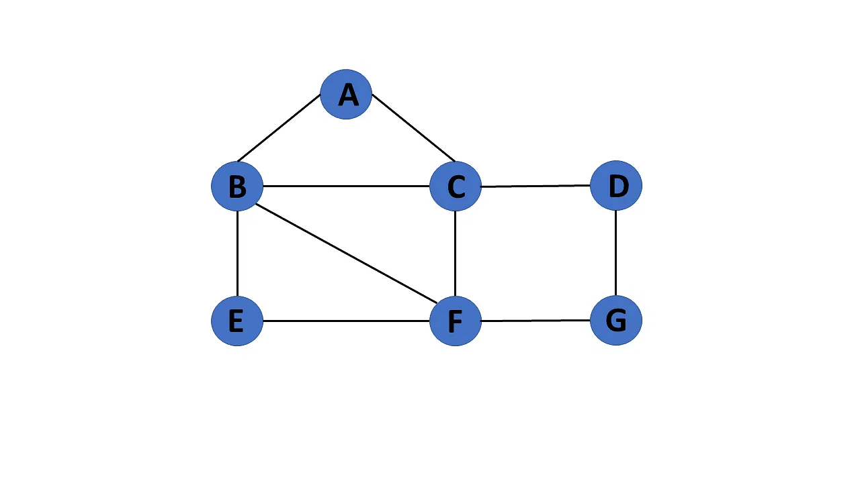
Starting vertex: F

Q. 3
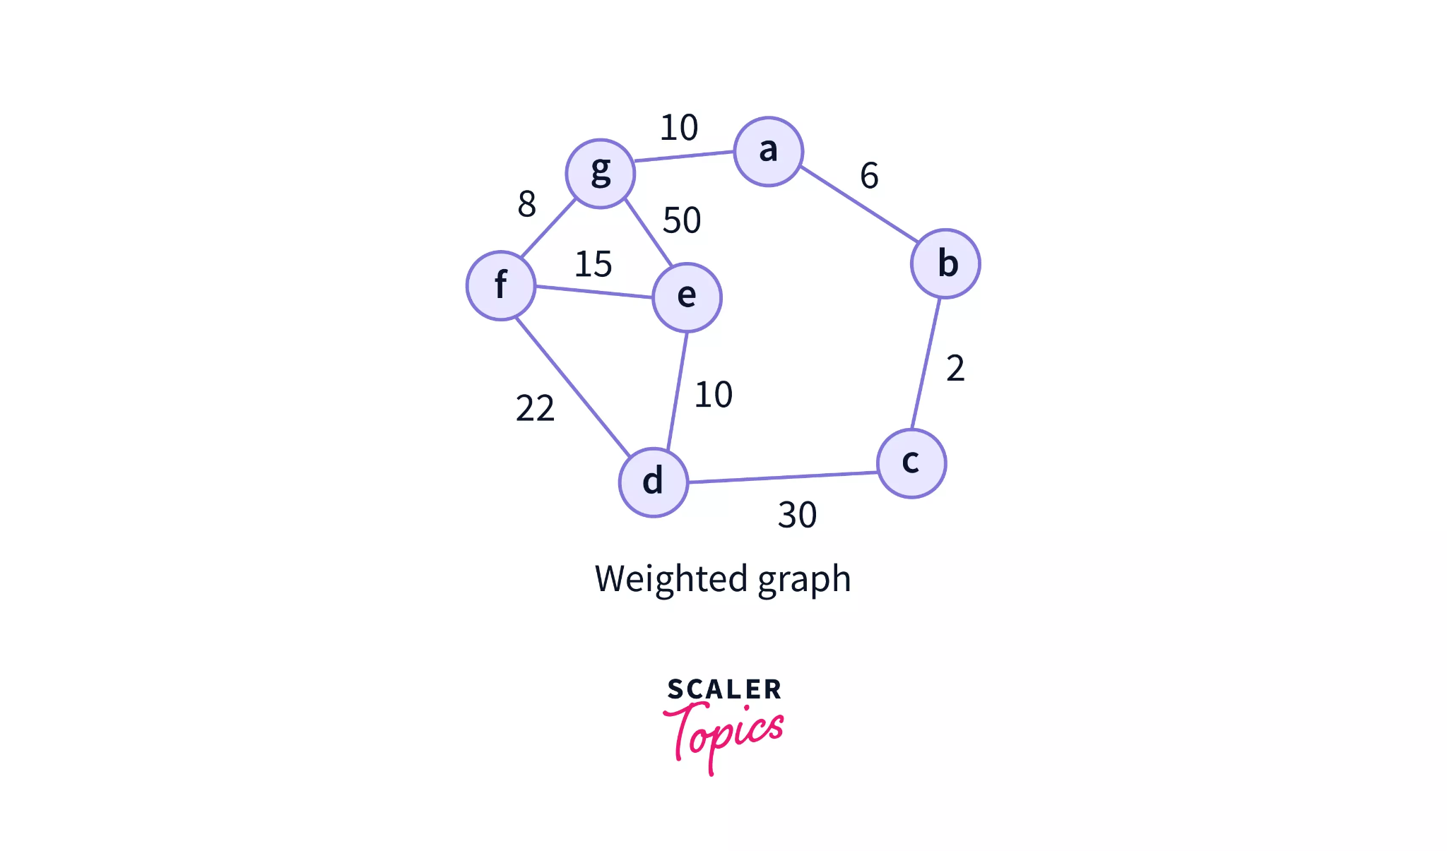
Starting vertex: d

Q. 4
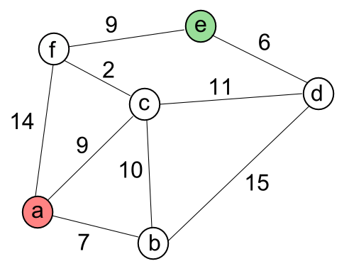
Starting vertex: f

Q. 5
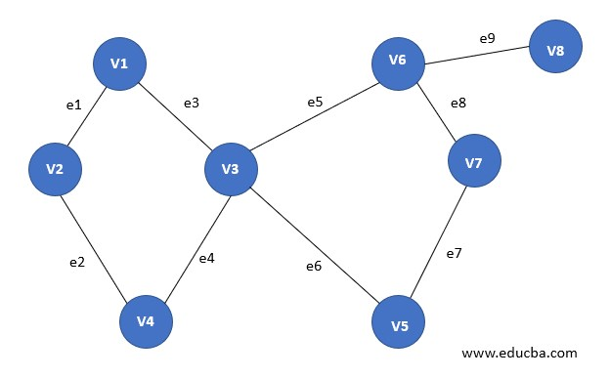
Starting vertex:v5

Q. 6
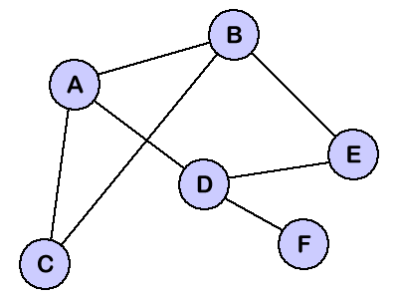
Starting vertex: f

Q. 7
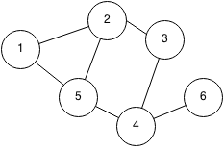
Starting vertex: 5

Q. 8
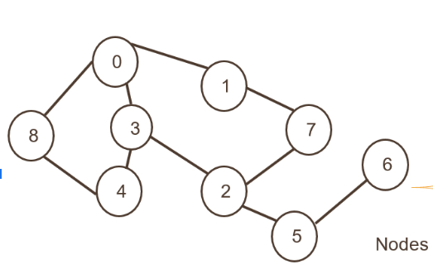
Starting vertex: 5

Q. 9
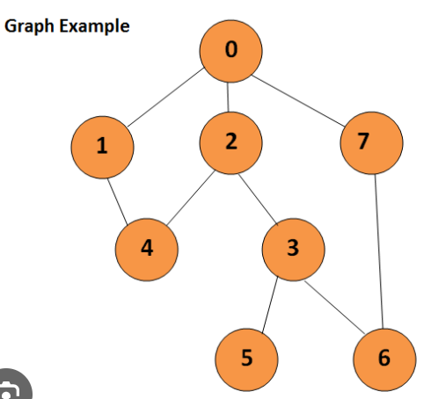
Starting vertex: 2

Q. 10
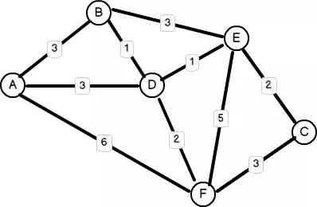
Starting vertex: F

Q. 11
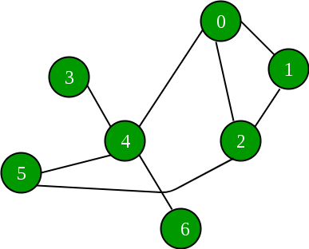
Starting vertex: 4

Q. 12
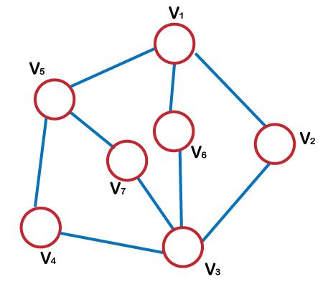
Starting vertex: V7

Q. 13
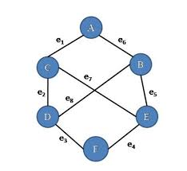
Starting vertex: B

Q. 14
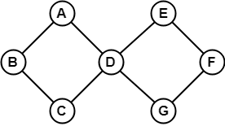
Starting vertex: G

Q. 15
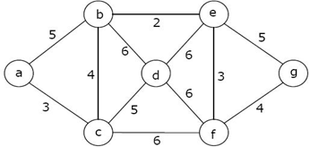
Starting vertex: g

Q. 16
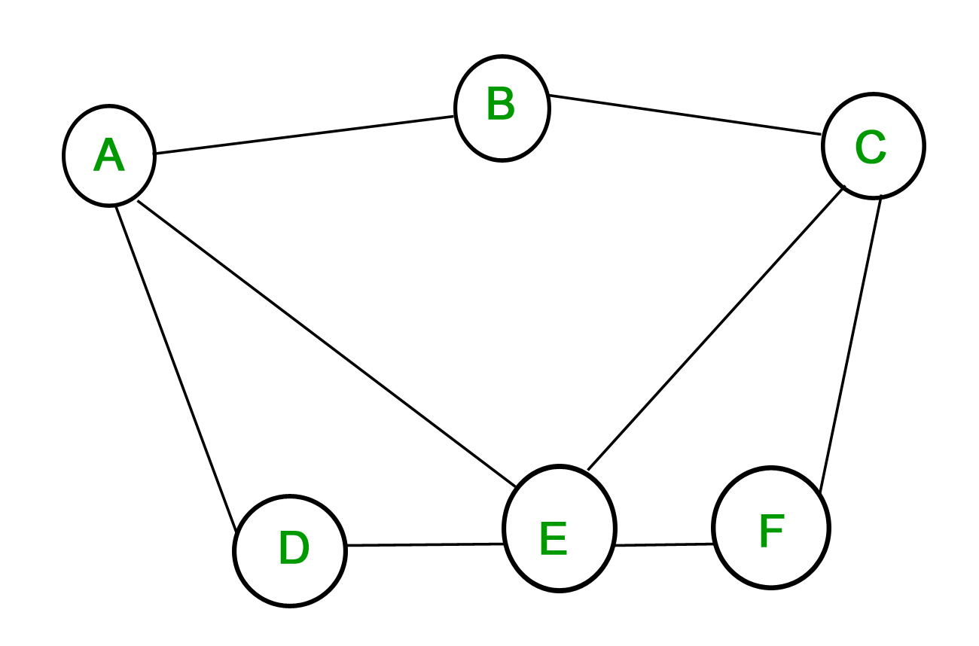
Starting vertex: F

Q. 17
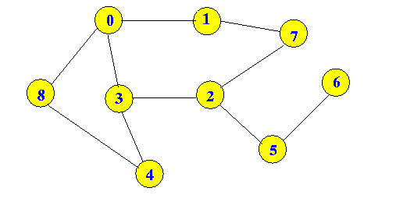
Starting vertex: 7

Q. 18
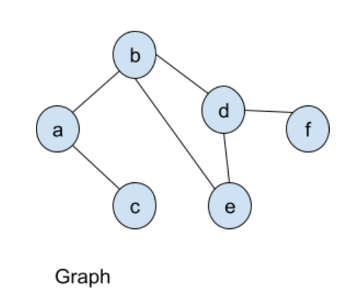

Starting vertex: d

Q. 19
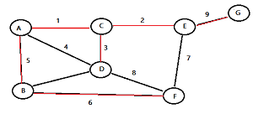
Starting vertex: B
Q. 20
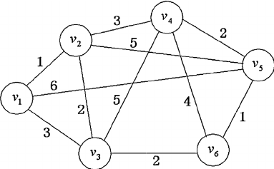
Starting vertex: V4

